**Errors Listing Report at the end of August 2016**

1. **Minus Deposit Balance at BMC**

**Customer ID: 4000017167**

**Customer Acc: 420000097984**

**Customer Name: MAT ROUSMAN**



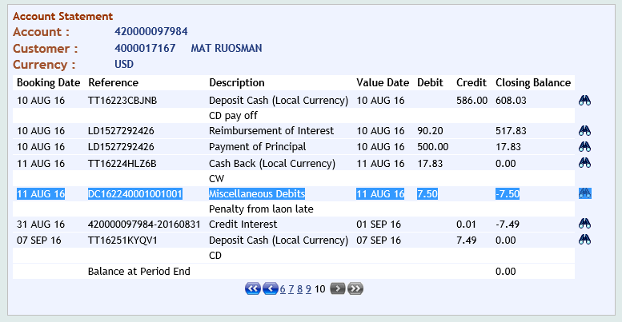

1. **Error Deposit Amount (1.24) at OLP:**

**Customer ID: 4000032829**

**Customer Acc: 460000013022**

**Customer Name: PRAK CHANLONG**

**Per CRC-T24**

**344330-AIP – Long Term – Time Deposit from Individuals – Resident**

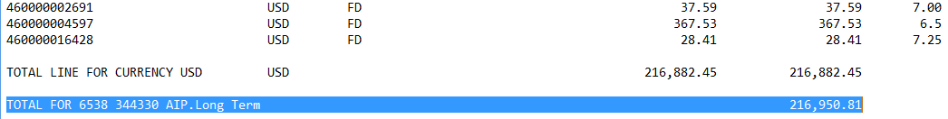

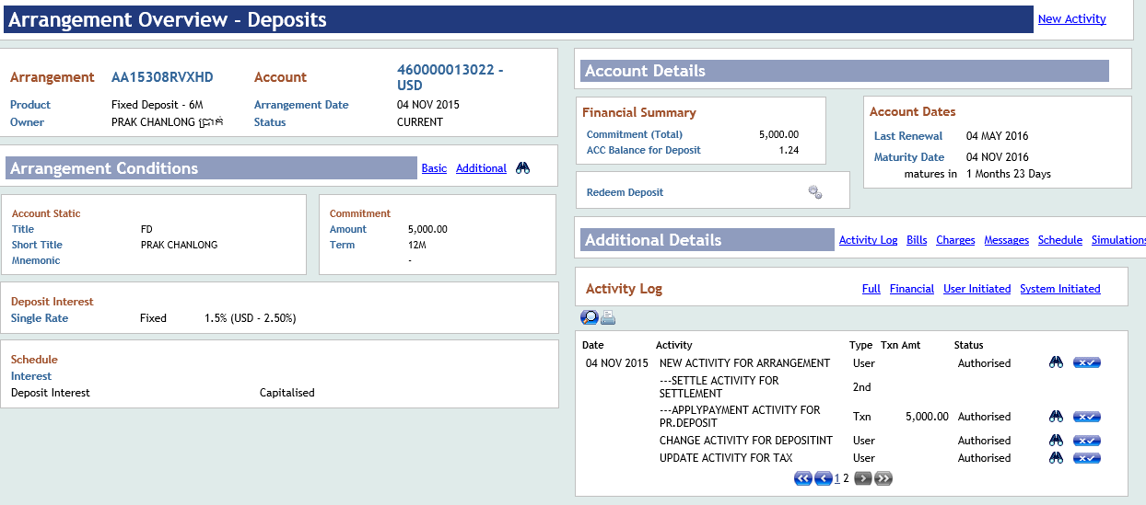

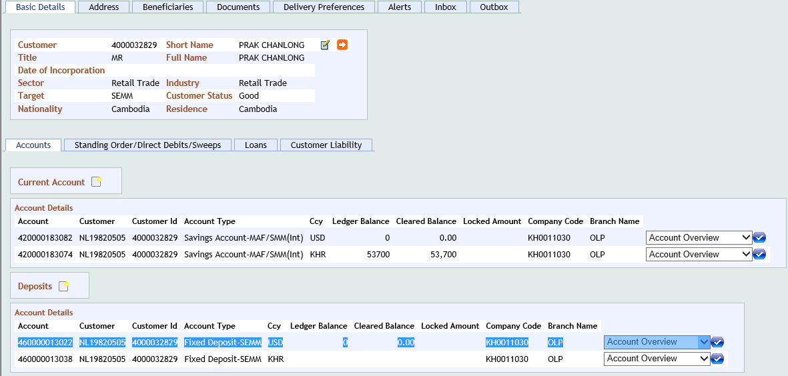

1. Loan Catch All at MBR:

Per CRB:

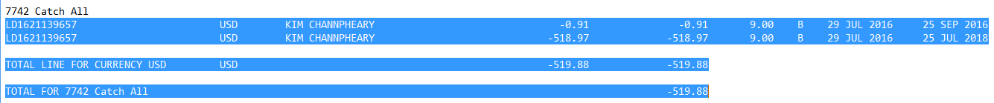

Per Listing:

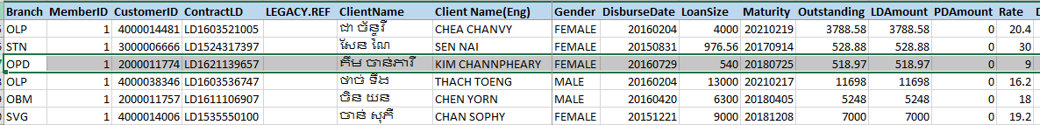

1. **Loan wrong class at STN:**

Customer ID: 4000017430

Customer Name: CHEANG NAY

Customer LD: LD1500501139

Day Due: 69 Days

* It show in Class 1 Per Listing and T24
* But Day Due: 69 days, it should be in class 2

**Per Listing:**

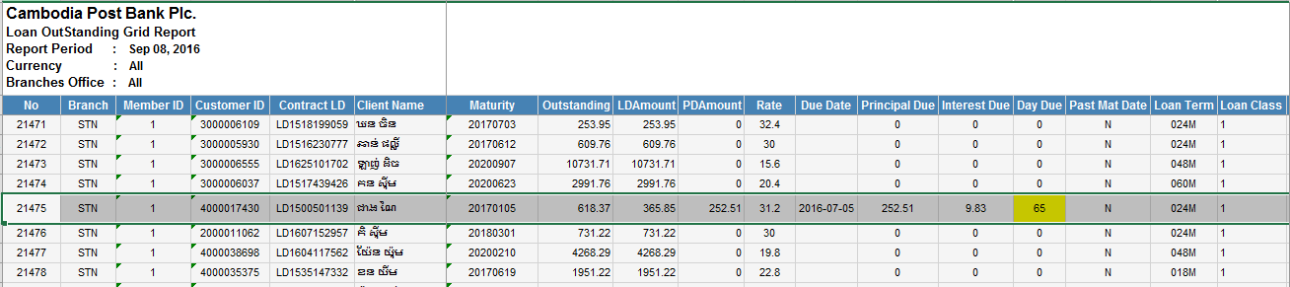

**Per T24:**

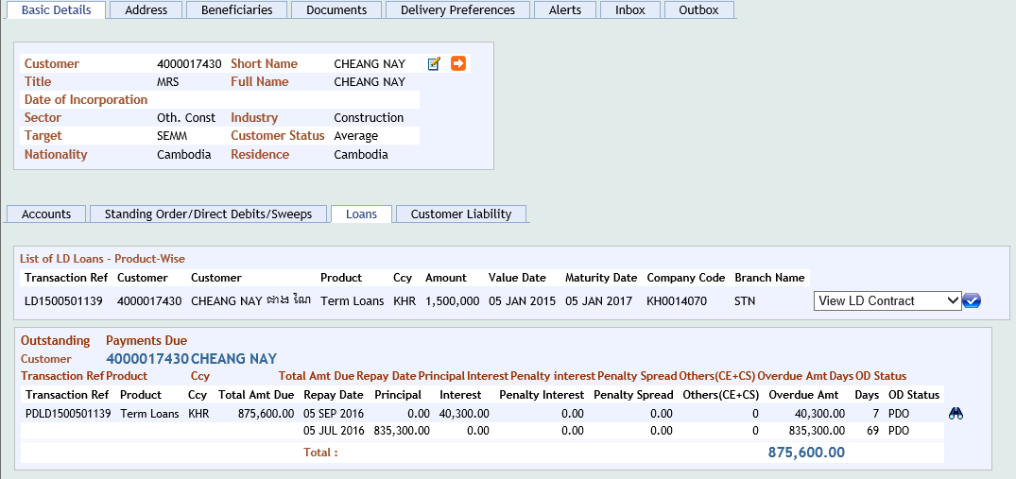

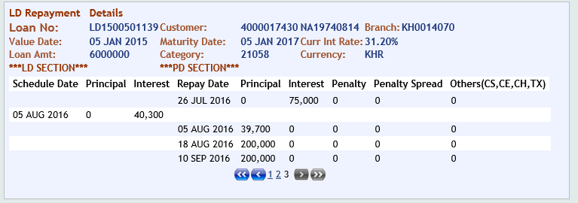

CRB

132370-Standard Loans – Other Long term Loans - Private Sector - Resident

